Raspberry Pi

A guide to facial detection

Table of Contents

Raspberry Pi 3

A guide to setting up your Raspberry Pi 3

Meet Raspberry Pi 4

Preparing SD card for installation: 5

Installing the Raspberry Pi NOOBS Operating System: 5

Setup Raspberry Pi Camera 7

Install OpenCV 4 on raspberry pi 9

Face Detection in OpenCV 11

# Raspberry Pi

The Raspberry Pi is a low cost, credit-card sized computer that plugs into a computer monitor or TV, and uses a standard keyboard and mouse. It is a capable little device that enables people of all ages to explore computing, and to learn how to program in languages like Scratch and Python. It’s capable of doing everything you’d expect a desktop computer to do, from browsing the internet and playing high-definition video, to making spreadsheets, word-processing, and playing games.

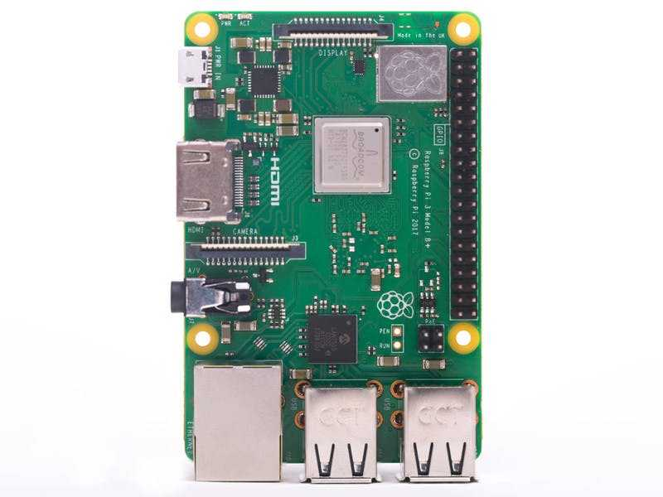

Figure 0‑1 Rasbperry Pi 3 Model B+

## A guide to setting up your Raspberry Pi

What you will need:

* SD Card: Minimum capacity of 8GB and a recommended capacity of 16 GB or 32GB
* Display Cable: Raspberry pi come with a HDMI port, So you need a HDMI cable to connect it with your monitor.   
   For VGA monitor , use a HDMI to VGA adapter
* Keyboard & Mouse: Standard USB Type A keyboard can be connected.  
   You can also use a wireless keyboard and mouse
* Power Supply: You need a good-quality power supply that can supply at least 2A at 5V for the Model 3B and 3B+, or 700mA at 5V for the earlier, lower-powered Pi models.
* Raspberry Pi Camera

## Meet Raspberry Pi

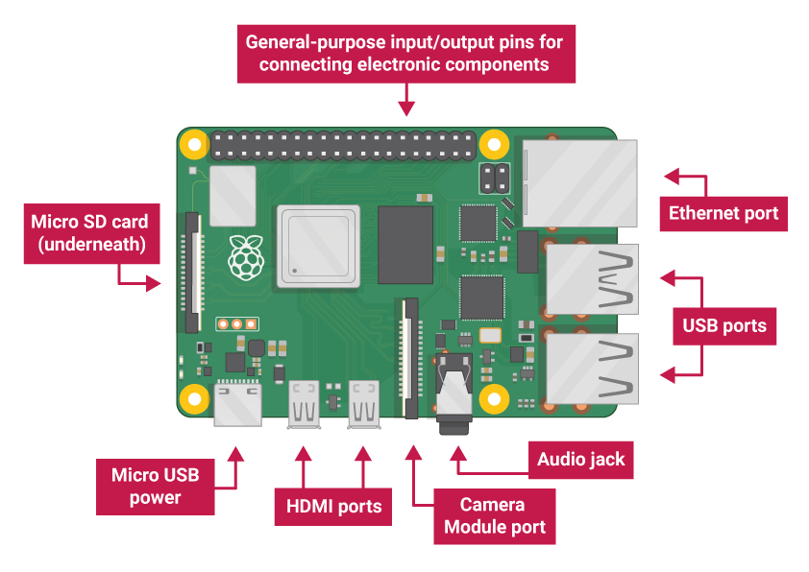

* USB ports — these are used to connect a mouse and keyboard. You can also connect other components, such as a USB drive.
* SD card slot — you can slot the SD card in here. This is where the operating system software and your files are stored.
* Ethernet port — this is used to connect Raspberry Pi to a network with a cable. Raspberry Pi can also connect to a network via wireless LAN.
* Audio jack — you can connect headphones or speakers here.
* HDMI port — this is where you connect the monitor (or projector) that you are using to display the output from the Raspberry Pi. If your monitor has speakers, you can also use them to hear sound.
* Micro USB power connector — this is where you connect a power supply. You should always do this last, after you have connected all your other components.
* GPIO ports — these allow you to connect electronic components such as LEDs and buttons to Raspberry Pi.

## Preparing SD card for installation:

* Go to site: <https://www.sdcard.org/downloads/formatter/>
* Scroll down the page and download the SD card formatter for windows
* Install the software
* Open the software 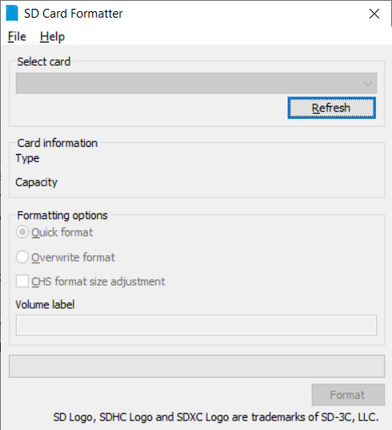
* Select the card
* Select the “Quick format” option from the Formatting options
* Click on format

**NOTE:** Please select the SD card location carefully. If any other drive is selected it will format that drive.

## Installing the Raspberry Pi NOOBS Operating System:

* Go to site: <https://www.raspberrypi.org/downloads/noobs/>
* Download the Noobs Zip file
* Unzip the zip file into your SD card.
* Insert the SD card into the raspberry pi.
* Connect the HDMI cable or HDMI to VGA convertor.
* Connect the Keyboard and mouse
* Connect the power supply.
* Follow the on screen instructions

# Setup Raspberry Pi Camera

Insert the Ribbon cable into the CSI port of the raspberry pi

* Turn on the raspberry pi
* Go the Raspberry pi menu
* Go into Preferences -> Raspberry Pi configuration -> Select the Interface TAB
* Enable the camera interface

How to take a still image?

* Open the terminal
* Enter the following command
* Raspistill –t 2 –o image.jpg

Note: The image will be saved in your current working directory

How to take video ?

* Open the termincal
* Enter the following command
* Raspivid –o filename.h264 –t 5000

Note: The video will be saved in your current working directory

# Install OpenCV 4 on raspberry pi

* Open the terminal: You can open the terminal from the icon on the screen. Or by pressing the “CTRL+ALT+t”
* Enter these commands in the following order:
* sudo apt-get update && sudo apt-get upgrade
* sudo apt-get install build-essential cmake unzip pkg-config
* sudo apt-get install libjpeg-dev libpng-dev libtiff-dev
* sudo apt-get install libavcodec-dev libavformat-dev libswscale-dev libv4l-dev
* sudo apt-get install libxvidcore-dev libx264-dev
* sudo apt-get install libgtk-3-dev
* sudo apt-get install libcanberra-gtk*
* sudo apt-get install libatlas-base-dev gfortran
* sudo apt-get install python3-dev
* cd ~
* wget -O opencv.zip https://github.com/opencv/opencv/archive/4.0.0.zip
* wget -O opencv_contrib.zip https://github.com/opencv/opencv_contrib/archive/4.0.0.zip
* unzip opencv.zip
* unzip opencv_contrib.zip
* mv opencv-4.0.0 opencv
* mv opencv_contrib-4.0.0 opencv_contrib
* wget https://bootstrap.pypa.io/get-pip.py
* sudo python3 get-pip.py
* sudo pip install virtualenv virtualenvwrapper
* sudo rm -rf ~/get-pip.py ~/.cache/pip
* Using a terminal text editor such as vi / vim or nano , add the following lines to your ~/.profile :
* export WORKON_HOME=$HOME/.virtualenvs
* export VIRTUALENVWRAPPER_PYTHON=/usr/bin/python3
* source /usr/local/bin/virtualenvwrapper.sh
* Enter the command
* source ~/.profile
* mkvirtualenv cv -p python3
* workon cv



* cd ~/opencv
* mkdir build
* cd build
* cmake -D CMAKE_BUILD_TYPE=RELEASE \

    -D CMAKE_INSTALL_PREFIX=/usr/local \

    -D OPENCV_EXTRA_MODULES_PATH=~/opencv_contrib/modules \

    -D ENABLE_NEON=ON \

    -D ENABLE_VFPV3=ON \

    -D BUILD_TESTS=OFF \

    -D OPENCV_ENABLE_NONFREE=ON \

    -D INSTALL_PYTHON_EXAMPLES=OFF \

    -D BUILD_EXAMPLES=OFF ..

* Increase the SWAP on the Raspberry Pi
* $ sudo nano /etc/dphys-swapfile



* sudo /etc/init.d/dphys-swapfile stop
* sudo /etc/init.d/dphys-swapfile start
* make -j4

**NOTE:** *After Executing make –j4 command. The system wil take a lot of time to compile the data. In any case DO NOT TURN OFF or Remove the power. There will be chances of corrupting the memory card. And then you have to start over.*

* Link OpenCV 4 into your Python 3 virtual environment
* cd ~/.virtualenvs/cv/lib/python3.5/site-packages/
* ln -s /usr/local/python/cv2/python-3.5/cv2.cpython-35m-arm-linux-gnueabihf.so cv2.so

## Face Detection in OpenCV

* Open the terminal
* Enter the following commands
* source .\profile
* workon cv
* nano facedet.py

then write the following code:

import numpy as np

import cv2

faceCascade = cv2.CascadeClassifier('Cascades/haarcascade_frontalface_default.xml')

cap = cv2.VideoCapture(0)

cap.set(3,640) # set Width

cap.set(4,480) # set Height

while True:

ret, img = cap.read()

img = cv2.flip(img, -1)

gray = cv2.cvtColor(img, cv2.COLOR_BGR2GRAY)

faces = faceCascade.detectMultiScale(

gray,

scaleFactor=1.2,

minNeighbors=5,

minSize=(20, 20)

)

for (x,y,w,h) in faces:

cv2.rectangle(img,(x,y),(x+w,y+h),(255,0,0),2)

roi_gray = gray[y:y+h, x:x+w]

roi_color = img[y:y+h, x:x+w]

cv2.imshow('video',img)

k = cv2.waitKey(30) & 0xff

if k == 27: # press 'ESC' to quit

break

cap.release()

cv2.destroyAllWindows()

* After writing Press the “CTRL+X”
* Enter “Y” and Press the Enter

Execute the script using the following command

* Python facedet.py